
South East European University
Faculty of Contemporary Sciences and Technologies

1st Project on Object Oriented Programming

Bank Management System

Student: Mentor:
Dardan Iseni Lejla Abazi-Bexheti
Tetovo, May 2020
Contents

Contents 2
1 Introduction 3
3 Problem description 4
4 UML of Project 5
5 Solution 6

Introduction

First of all this project is developed in C++ Language by a student of computer sciences at South East European University-Faculty of Contemporary Sciences and Technologies

The project was as a result of an ending semester and the objective was to apply all C++ Programming knowledge including different algorithms,classes and objects,inheritances,polymporphisms except files,on a real world project.

So I decided to create a management system that will help to manage clients and employers of a “tiny” business.In this case I decided to develop a Bank Management System where an admin will have a variety of options for his clients and employers

I dedicate this project to all students who wants to learn more on C++ programming language from a real university project,from a real world project,including a variety of algorithms,optimized boolean expressions and a lot of other stuff.

Project Problem

My idea on this project as I said before was to create a Bank Management System where the admin will be the head of the project.
He will be able to do a variety of things on two main classes User(Clients) and Employers like adding them,sorting,filtering,manipulating their data and also to print their data.
As all projects that has different requirements this project had a plenty of them too.
Here are some of the requirements:
- Including classes and objects
- Different Inheritances(Multilevel,Hierarchical,Hybrid)
- Virtual and Pure Virtual functions
- Separating interface from implementation
- Overloaded functions
- Documentation

Everything was clear for me but the main issue was to implement both,the virtual and pure virtual function because I needed maximum one virtual function in my project.

UML of Project

Here is a basic UML that shows how the project works:

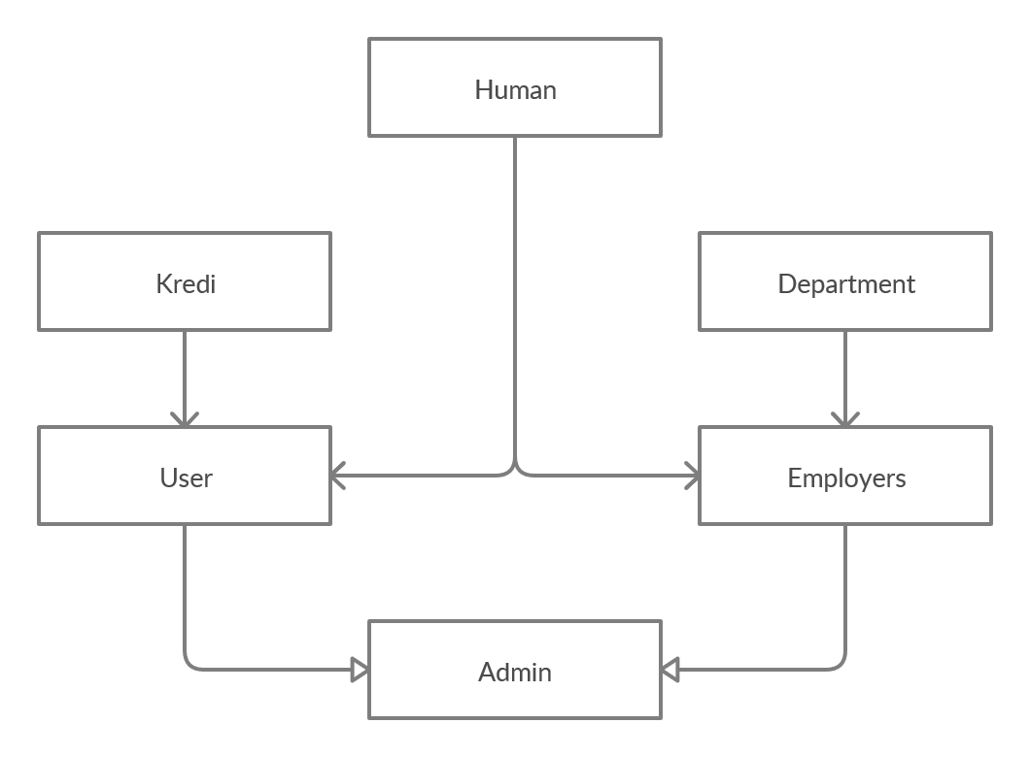

Solution
As we can see on the UML graph we have in total six classes.
The first class is “HUMAN” which contain basic information’s for users and employers like name surname id city and all set and get function that are needed for them.This class is a base class which inherit to two main classes User and Employer so this is an hierarchical inheritance.
Also we have two classes that inherit with single level inheritance Credit and Department.
Credit class inherit to User and has private variables needed for credits like interest value of credit rate and installments,their set get functions and the main function here is calculating credit which calculate automatically the credit depends on previous variables.
Department inherit to Employer and has variables needed for department job position experience and salary.Set and get funtions also as we know but what is characteristic here that set functions are not like others where we just set the variable on the parameter of the function thoose set functions when we call they list their choices and add them to the function.
Two important classes that inherits all these classes are User and Employer.
The User class as I mentioned inherits from Human and from Credit and has private members like income outcome deposit and as public we have here a virtual function Print Users that helps us to print users at derived class and this class too.
The Employer class is quite similar to the User class just with a tiny difference it inherits from department not from Credit.We have also here a virtual function called Print Employers.

And for the and we have Admin class which inherits from both User and Employer and this form a hybrid inheritance.In this class we have a variety of functions that help us do some cool stuff like adding and printing users/employers,sorting,filtering them.We have a function called calculate salary which calculate salary depend position and department of the employer and set his salary.
We have virtual functions as I mentioned earlier Print Users and Print Employer and an overloaded function called add from main which help us add from the script Users or employers.

An amazing feature is at calculate salary where I optimized boolean expression from a long one to much shorter.
For this optimization I used Boolean Algebra laws or to be more specific Distributed Law.

Below it’s the code how would look without boolean optimization:

if (employee[numofemployes].getposition() == "Intern" && (employee[numofemployes].getdepartment() == "Finance"||
if (employee[numofemployes].getposition() == "Intern" && employee[numofemployes].getdepartment() == "Accounting"||
if (employee[numofemployes].getposition() == "Intern" && employee[numofemployes].getdepartment() == "Loan Office"||
if (employee[numofemployes].getposition() == "Intern" && employee[numofemployes].getdepartment() == "Executive"||
employee[numofemployes].setsalary(0);

And here is how it looks now:

if (employee[numofemployes].getposition() == "Intern" && (employee[numofemployes].getdepartment() == "Finance"||

employee[numofemployes].getdepartment() == "Accounting"||

employee[numofemployes].getdepartment() == "Loan Office"||

employee[numofemployes].getdepartment() == "Executive"))
employee[numofemployes].setsalary(0);

